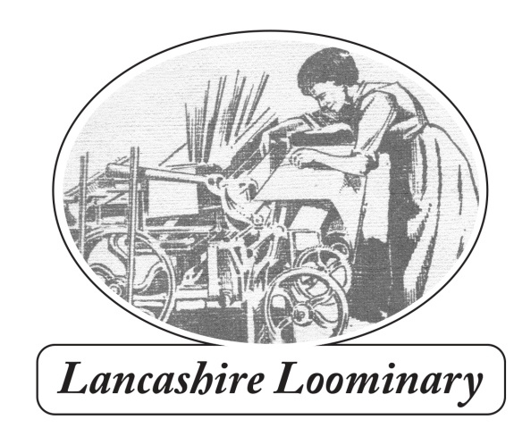
109 Harpers Lane BOLTON BL1 6HU
Phone: 07795 008691 email: paul.salveson@myphone.coop
www.lancashireloominary.co.uk
ORDER FORM 2021 (including Special Offers)
Name..............................................................................................................
Delivery Address......................................................................................................................................
........................................................................................................................Post code.........................
Phone........................................................................................email......................................................
Quantity | Title | Price ( + delivery)
 | The Works (special offer) | 5.00 + £3
 | Allen Clarke/Teddy Ashton: Lancashire’s Romantic Radical (new edition). SEE BELOW FOR COMBINED OFFER | 15.00 + £3
 | With Walt Whitman in Bolton (special offer) | 5.00 + £3
 | Moorlands, Memories and Reflections | 20.00 + £4
 | Will Yo’ Come O’ Sunday Mornin’? Winter Hill Trespass of 1896 | 5.00 + £3
 | The Settle-Carlisle Railway | 24.00 + £4
 | Allen Clarke and Moorlands books – combined offer | 30.00 + £4
 | Total
Bundles by negotiation! If ordering more than 1 book postage is £4 in UK. Local delivery is by Bolton Bicycling Bookshop, otherwise Royal Mail. Enquire for overseas rates.
Send cheque for total amount made to ‘Paul Salveson’ to 109 Harpers Lane, Bolton BL1 6HU.
If paying by BACS the account details are:
Dr P S Salveson (it’s a personal account) sort code 53-61-07 A/C no. 23448954. Email me your order details and put your name and book e.g. ‘MMR’ ‘AC’ or ‘Works’ as the reference when paying. I’m happy to sign books, but please let me know (and to whom, if you want a specific dedication).
Many thanks for your support. Paul

