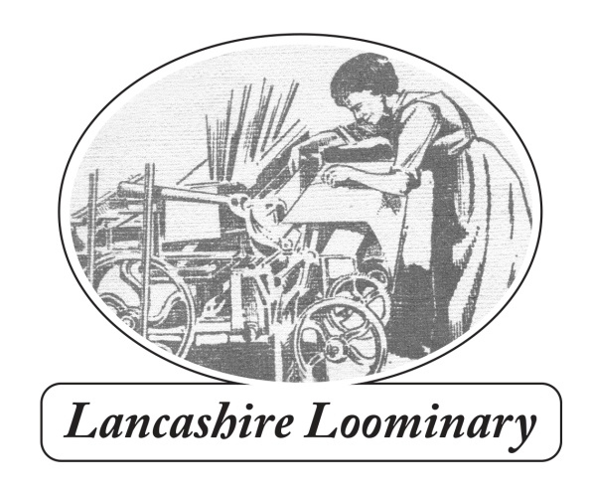
109 Harpers Lane BOLTON BL1 6HU
Phone: 07795 008691 email: paul.salveson@myphone.coop
www.lancashireloominary.co.uk
ORDER FORM
Name..............................................................................................................
Delivery Address......................................................................................................................................
........................................................................................................................Post code.........................
Phone........................................................................................email......................................................
Quantity | Title | Price ( + delivery)
 | The Works (see special offer below) | 10.00 + £3
 | Lancashire’s Romantic Radical: Allen Clarke/Teddy Ashton | 10.00 + £3
 | With Walt Whitman in Bolton | 8.00 + £3
 | Moorlands, Memories and Reflections | 21.00 + £4
 | Will Yo’ Come O’ Sunday Mornin’? Winter Hill Trespass of 1896 | 5.00 + £3
 | The Settle-Carlisle Railway | 24.00 + £4
 | Bolton Lancashire Facemask | 6.00 + £2
 | Total
Bundles by negotiation! Current special offer is 3 copies of The Works for £20 (plus £5 postage if applicable) and £20 for 3 copies of With Walt Whitman. If ordering more than 1 book postage is £5
Local delivery is by Bolton Bicycling Bookshop, otherwise Royal Mail. Enquire for overseas rates.
Send cheque for total amount made to ‘Paul Salveson’to 109 Harpers Lane, Bolton BL1 6HU.
If paying by BACS the account details are:
Dr P S Salveson (it’s a personal account) sort code 53-61-07 A/C no. 23448954.Please email me with your order details and put your name and book e.g. ‘MMR’ or ‘Works’ as the reference when paying.
I’m happy to sign books, but please let me know (and to whom, if you want a specific dedication).
Many thanks for your support. Paul

