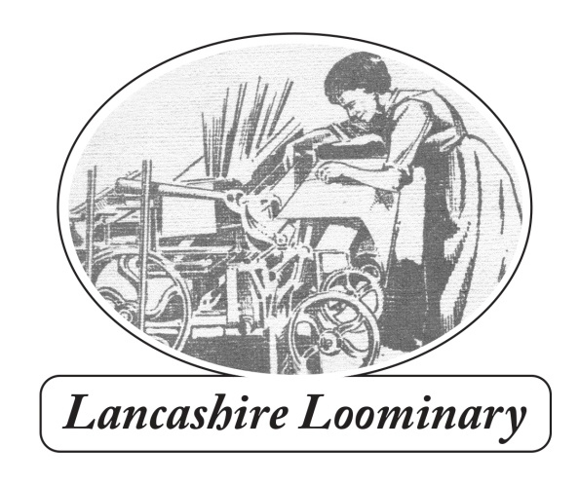
109 Harpers Lane BOLTON BL1 6HU
Phone: 07795 008691 email: paul.salveson@myphone.coop
www.lancashireloominary.co.uk
ORDER FORM
Name..............................................................................................................
Delivery Address......................................................................................................................................
........................................................................................................................Post code.........................
Phone........................................................................................email......................................................
Quantity | Title | Price ( + delivery)
 | The Works | 10.00 + £3
 | Lancashire’s Romantic Radical: Allen Clarke/Teddy Ashton | 10.00 + £3
 | With Walt Whitman in Bolton | 10.00 + £3
 | Moorlands, Memories and Reflections | 21.00 + £4
 | Will Yo’ Come O’ Sunday Mornin’? Winter Hill Trespass of 1896 | 5.00 + £3
 | The Settle-Carlisle Railway | 24.00 + £4
 | Northern Rail Heritage (new edition out soon) | 6.00 + £3
 | Total
Bundles by negotiation (gets complicated).
Local delivery is by Bolton Bicycling Bookshop
For multiple copies postage is the same as for one, as above. Please enquire for overseas rates.
Send to 109 Harpers Lane, Bolton BL1 6HU with cheque for total amount made to ‘Paul Salveson’.
If paying by BACS the account details are:
Dr P S Salveson sort code 53-61-07 A/C no. 23448954.Please email me with your order details.
I’m happy to sign books, but please let me know (and to whom, if you want a specific dedication).
Many thanks for your support. Paul

